## **Dungeons and Dieting**

## **Theme / Setting / Genre**

* Fantasy Setting
* Dieting Application
* Incentivise Good Eating Habits
* Location based

## **Core Gameplay Mechanics Brief**

- **<Gameplay Mechanic #1>**

Diet Tracking (Food/Calories Recorder)

**- <Gameplay Mechanic #2>**

Weapon System

**- <Gameplay Mechanic #3>**

Fighting System

**- <Gameplay Mechanic #4>**

Quest system

**- <Gameplay Mechanic #5>**

Shop system

**- <Gameplay Mechanic #6>**

Nest system

**- <Gameplay Mechanic #7>**

Party system

**- <Gameplay Mechanic #8>**

Inventory system

**Areas of Interest**

* Augmented Reality (AR Kit 2)
* Motion Controls (Core Motion)
* GPS (CoreLocation MapKit)
* Camera
* Achievements (GamePlay Kit)
* Leaderboards (GamePlay Kit)

**Influences**

**- <Influence #1>**

**Pokemon Go**

The reason why we chose this game is because of its gps gameplay for walking

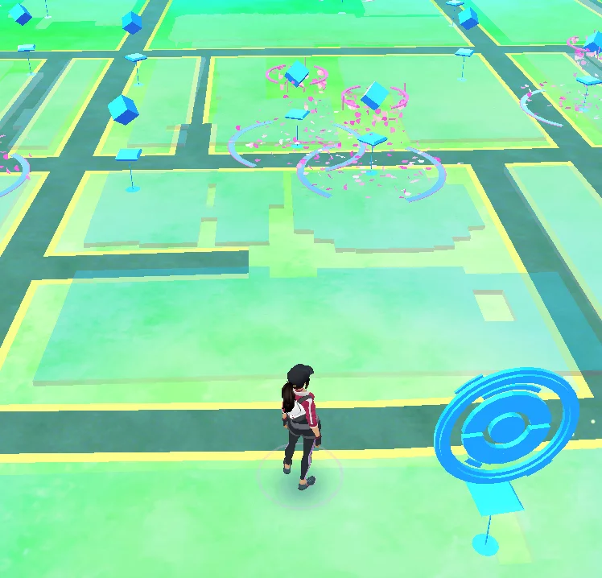

**- <Influence #2>**

**Dragon Quest Walk**

we chose this game is because of its unique gameplay style we believe that this game can give us inspiration into the battle mechanics of the app whistle integrate to gps gameplay similar to that of Pokemon go

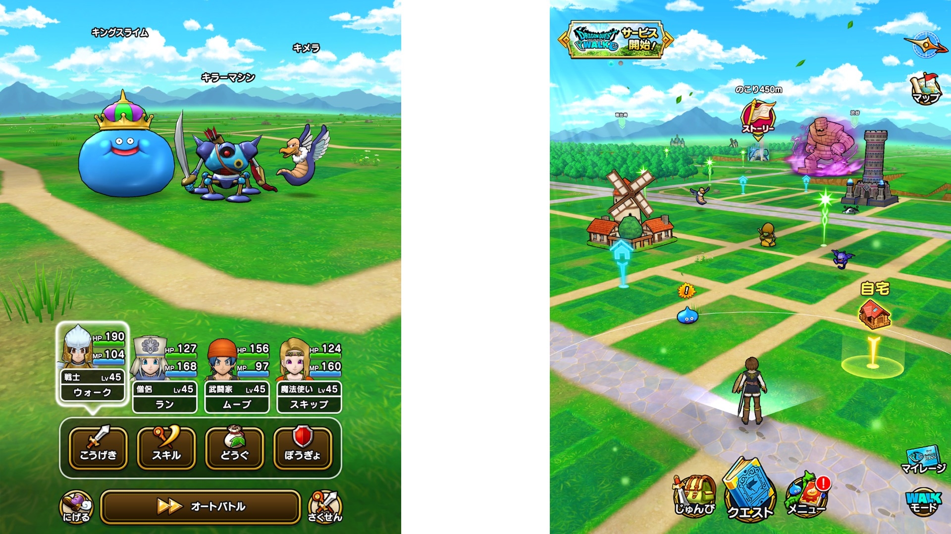

**- <Influence #3>**

**Habitica**

We believe that this app will help us organize players progress in there diet as well help us with our quest and inventory system

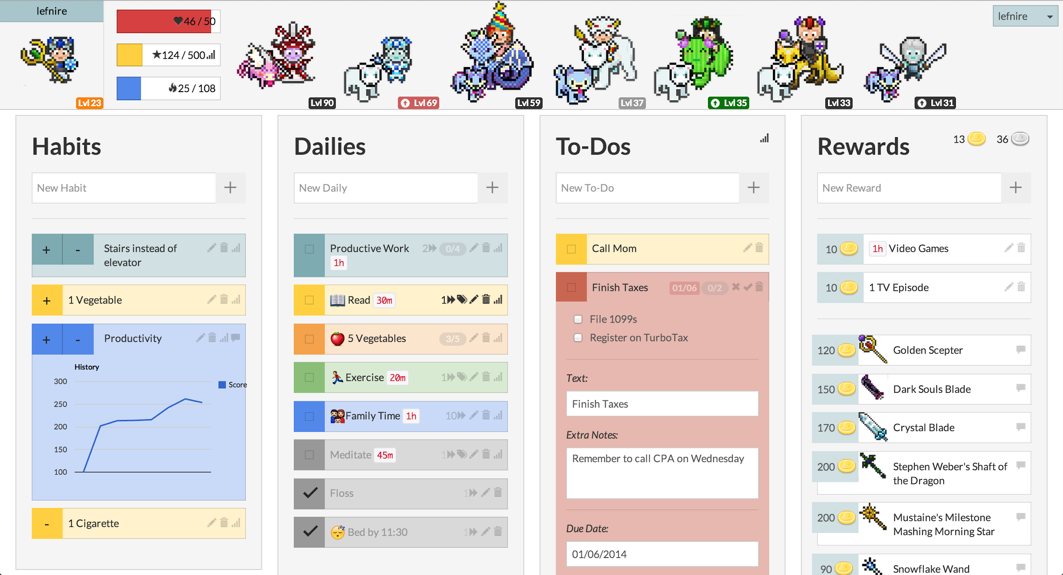

## **The Elevator Pitch**

Do ever wish dieting and getting fit was fun? This app tracks your exercise routine as well as well the food you eat in order to gain experience to help you fight monsters in battles.

## **Project Description**

Dungeons and Dieting is an application that tries both to record a users’ calories count and what they take and encourages walking in-game so the users may go on a “quest” to fight a monster**.**

# **What sets this project apart?**

**<Reason #1>**

This app will make dieting a fun experience by making it to a competition

**<Reason #2>**

Makes the exercise the player will do feel more like an adventure more

**<Reason #3>**

Will promote healthier dieting while also tracking your progress

**Why would users use the app?**

* A way to make dieting fun and more enjoyable
* Makes notes of what the user ate so that they have an appmate amount of calories they have taken in a day
* Have the player do mild cardio by using the app when finding monsters to fight
* Will be able to work together/compete with friends and family
* Makes notes on where you have traveled

**How users travel through the app**

* Home screen

1. Play
2. Setting

* Sfx
* Master volume
* Map screen
  1. Shop
  2. Inventory screen
  3. Nest system
  4. Party system

Party member namer

* Progress screen

1. Dieting tracker

* Food
* Calories counter

1. Player info screen

* Name
* Where you live(country)
* Current Weight
* Weight lossed
* Experience Bar
* Level
* Location
* Leaderboard

**Core Gameplay Mechanics (Detailed)**

**- <Core Gameplay Mechanic #1>**

Diet Tracking (Food/Calories Recorder)

**- <Details>**

Player will be tracking there calories and what they eaten

**- <How it works>**

Food recorder: When the user is uses a camera the image will be saved in a record folder that holds on to all the images of food you have taken

Calories recorder: user insert the current weight then using gps tracking it will calculate the distance minus the user current weight the saved of the calorius lost

**- <Core Gameplay Mechanic #2>**

Weapon System

**- <Details>**

Player can choose a weapons for their avatar to fight monster

**- <How it works>**

When a user has found weapon there avatar can use either getting one from a monster or store they can equip it to the avatar to increase their status

**- <Core Gameplay Mechanic #3>**

Fight System

**- <Details>**

Turn based fighting system where the player can choose to attack, defend, use items, or run away.

**- <How it works>**

When the user walks close to a nest they can then interact with it. They will then begin a small battle to fight the monster they find in the nest. There the player will begin combat and try to win.

**- <Core Gameplay Mechanic #4>**

Quest system

**- <Details>**

The user will set the distance they would like to walk to or a specific eating goal

**- <How it works>**

The player will be able to select a daily task depending on the difficulty level of the player on the map of the game there will barrier on how far they need to walk Note the player chose where they want to walk in the area

**- <Core Gameplay Mechanic #5>**

Shop system

**- <Details>**

Player buys equipment or consumables to use for battles

**- <How it works>**

The player earns money from defeating monsters in battles. They access the shop through the main menu.

**- <Core Gameplay Mechanic #6>**

Nest system

**- <Details>**

The Nest is the goal you walk to in order to reach the start of a battle

**- <How it works>**

The player scrolls on the map of the real world and places a marker they then have to walk to. The distance has to be a certain distance away and the area where they can’t place it will be darker to indicate this

**- <Core Gameplay Mechanic #7>**

Party system

**- <Details>**

Players can form a party with friends in order to compete against other parties

**- <How it works>**

Way for you and your friends to team up in a party. The stats of the party will be in a leaderboard and you compete with other parties for the weekly highest rank. The winner will get a prize. Players will also be able to see each food intake though photos of what the user took and they will also be able to see the calorie count

**- <Core Gameplay Mechanic #8>**

Inventory system

**- <Details>**

Holds player’s equipments and consumables

**- <How it works>**

When the player defeats a monster the item will go into the inventory menu where the player can select the item if the item is a weapon player can choose to equip/unequip it, sell it etc if the item is a consumable the player can choose to use it to heal themselves